**Sunspot classification using artificial intelligence**

Eduard Plic

Keywords: sunspots; artificial intelligence; convolutional neural networks; McIntosh classification; sunspot drawing

Top of Form

# Introduction

The main motivation of this work was to explore the potential use of artificial intelligence in solar astronomy, specifically in the classification of sunspots. The term "artificial intelligence" has become widely known, especially with the rise of chatbots and image-generating programs, and it is often misinterpreted and misused. At the same time, there is a trend to start utilizing these new tools in various fields, and this work aims to provide a proof of concept that machine learning can indeed be integrated into solar observatories.

The second goal was to demonstrate that it is possible to create a machine learning model capable of predicting the classification of an active region of the Sun according to McIntosh's classification system. This model would be developed based on solar drawings that depict groups of sunspots.

We decided to use handdrawn data, rather than satelite ones, because there are way more cool.

# Sunspots

Sunspots are dark areas on the Sun’s photosphere, first recorded in ancient Asia and studied more closely after the telescope’s invention in the 17th century. Caused by magnetic field distortions during the 11-year solar cycle, they feature a dark umbra (althrought 4000 K) and a lighter, filamented penumbra. These spots are observable in the visible spectrum, as shown in Figure 2. Their size, shape, and distribution vary, making them key to understanding solar activity and forecasting eruptions and auroras.

## Groups of Sunspots

Paradoxically, a sunspot group can be a single spot, as it represents a closed system. Groups may range from one to dozens of spots, with size, structure, and spot count affecting their lifespan—from a few hours to several weeks. On Figure 2, there are aproximately 4 groups.

## Classification of Active Regions

Sunspot groups, or active regions, vary widely, leading to the development of multiple classification systems based on size, polarity, and distribution. These aim to improve solar activity and therefore eruption prediction. At this time, there is no adequate method for accurately predicting the formation of eruptions, as this remains a very complex task.

### McIntosh Classification

Figure 9: Summary image for McIntosh classification [23]

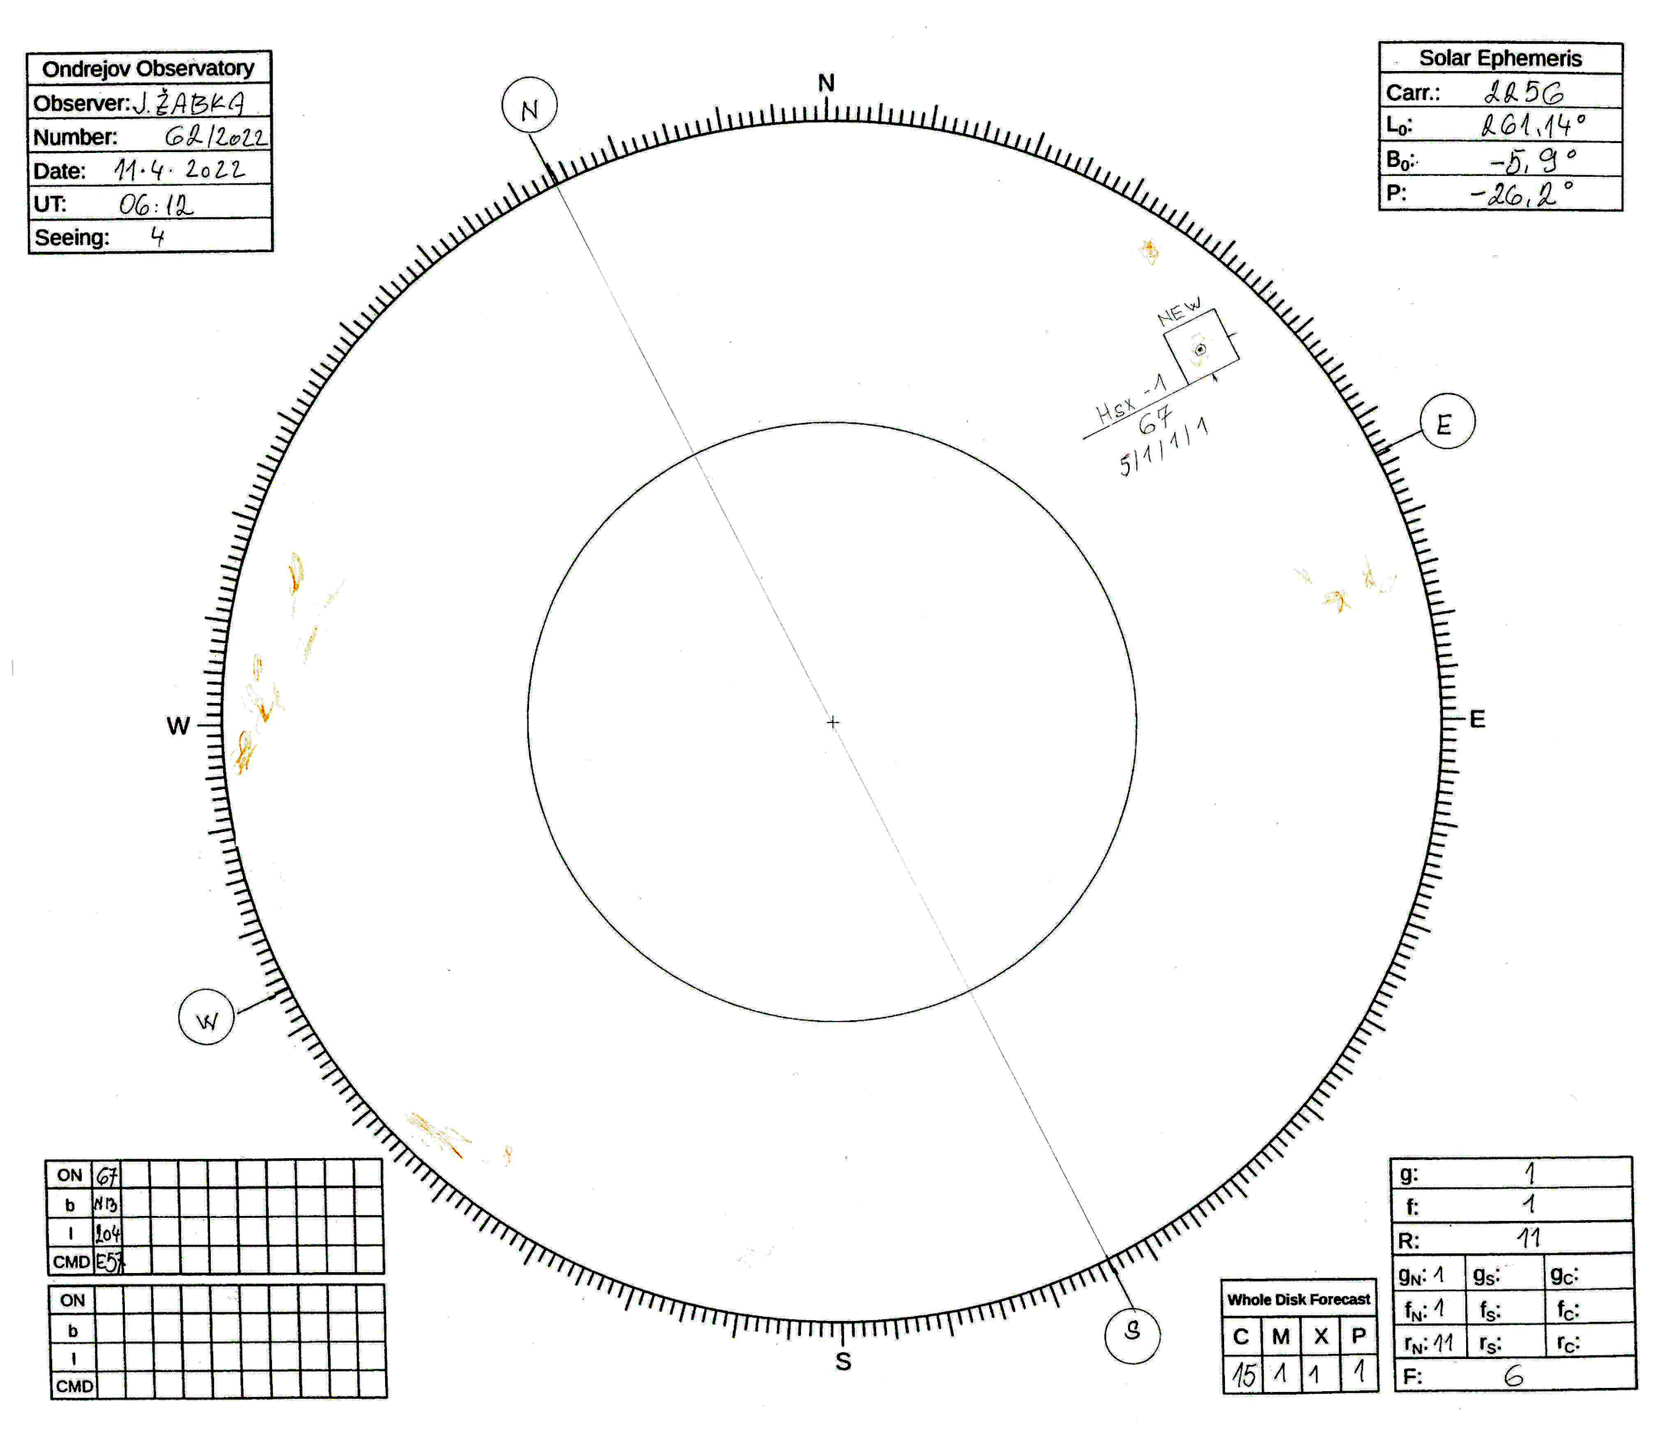The McIntosh classification, developed in 1966, consists of three different, nearly independent classifications that together determine a three-letter designation for the group (see Figure 9). Spots can thus be designated, for example, as Axx, Dai, or Eso. The first letters are A, B, C, D, E, F, H and refer to overall size of group, the second letter, one of x, r, s, a, h, k; characterizes the penumbra of largest spot in the group, and the third symbol, letters x, i, o, c; characterizes the distribution of spots in the group. For examples and detailed descripsion of classes see Figures 25 and 35.

Figure 12: Illustrative drawing from the observatory of the Astronomical Institute in Ondřejov [28]

## Sunspot Drawing

Figure 13: Illustrative example of using a telescope to project the Sun onto a protocol [29]

Sunspot drawing, first used by Galileo, involves projecting the Sun onto paper via a telescope and sketching the observed features, as seen in Figure 12. This practice represents a continuous observational record dating back to the 17th century, yet only a few Czech observatories still engage in it regularly. The Astronomical Institute is one such institution, offering many of its drawings for free download. In Ondřejov, home to one of the Institute's observatories, solar observation has a long tradition, with the first publicly available drawing dating back to 1944 and archives including data captured during World War II on photographic plates. While some may argue that solar drawing is unnecessary in today's digital age, it still provides valuable insights. Comparing both data helps us understand periods when only drawings were available.

### Information in the Record

The record must include various information: the date and time of the drawing, the observation location, and the observer's name, observing conditions, the number of drawing. Furthermore, the record should also contain data about the solar disk: the heliographic latitude and longitude of the solar disk center, the angle by which the rotational axis of the Sun is tilted, and the Carrington rotation number. The drawn groups of spots should be outlined in a rectangle and numbered, possibly also classified. The record should also include information about solar aktivity like number of facula fields, the Wolf number, the number of spots and groups on the disk, and distrubution of these into three sectors: central, northern, and southern. The record should also include information on the location of each group, namely the heliographic latitude and heliographic longitude of the center of the group, as well as their position relative to the center of the drawing. Heliographic coordinates of the group can be calculated using the following formulas: [26]

$ρ=\sin^{-1}{\frac{vz}{R}}$ (3)

$b=\sin^{-1}\left(\sin{B_{0}}\cos{ρ}+\cos{B_{0}}\sin{ρ\cos\left(P-Q\right)}\right)$ (4)

Figure 14: Occurrence of data in the drawing [32]

$l=\left(\sin^{-1}{\frac{\sin{ρ}\sin\left(P-Q\right)}{\cos{b}}}\right)+L_{0}$, (5)

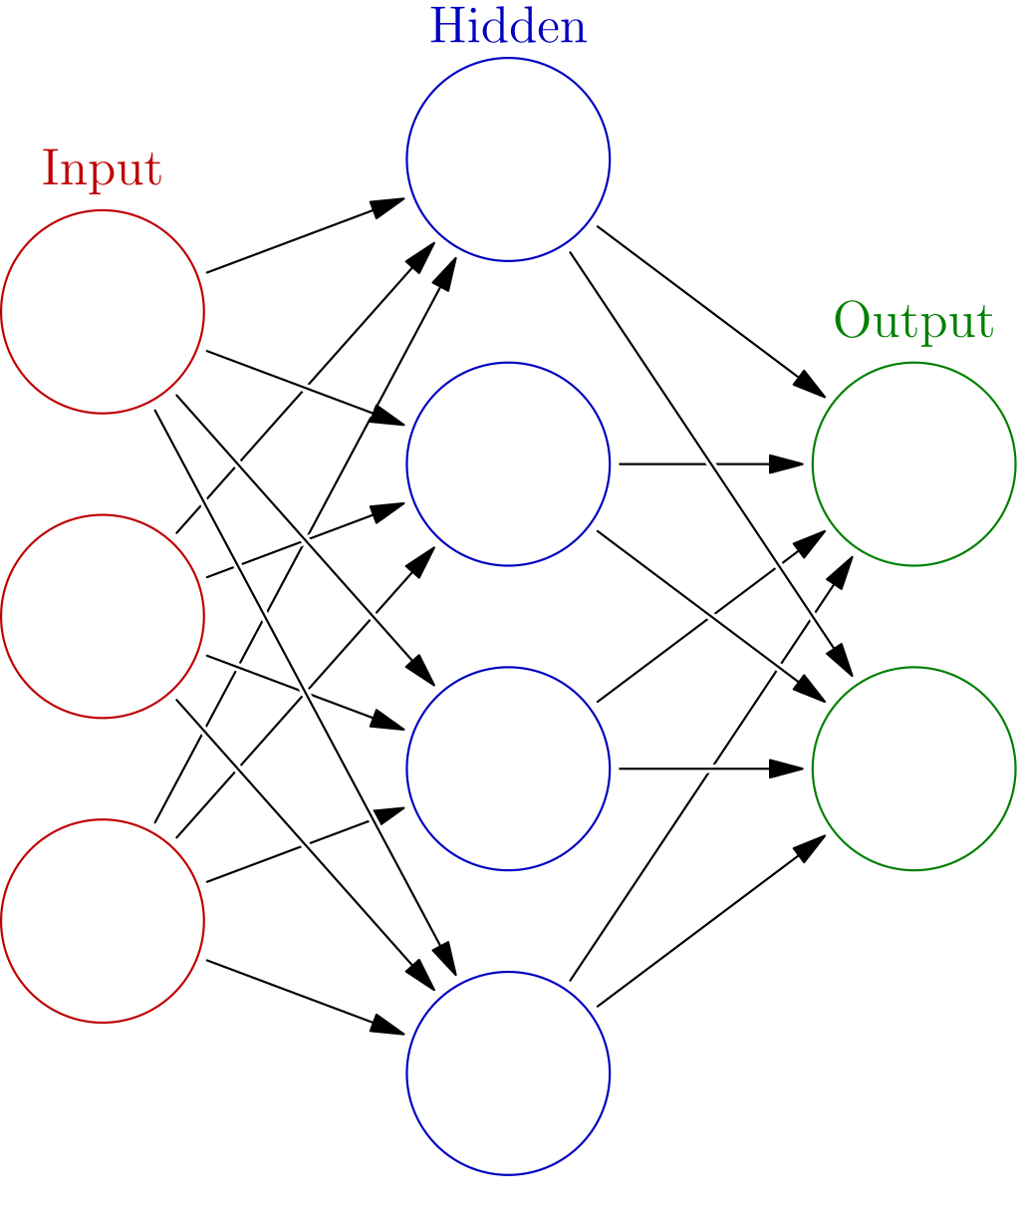where variables are shown and explained on Figure 14.The letters *b* and *l* are the sought heliographic coordinates, latitude and longitude, of the group.

Figure 15: Example of a feedforward neural network [37]

# Machine Learning

Figure 16: The process of calculating the value of a neuron

Machine learning refers to methods and algorithms used to perform tasks like categorization, prediction, similarity detection, or content generation. It powers applications from smart car vision to stock forecasting and tools like ChatGPT and DALL-E. A common approach to train a model is supervised learning, where input data is paired with correct outputs. The model learns patterns from data, such as image recognizing cars and dogs, and improves based on feedback.

## Neural Networks

Neural networks are made of neurons that activate based on values from previous neurons through simple mathematical operations. Each neuron connects to all neurons in the previous layer, with varying connection weights $w_{i}$.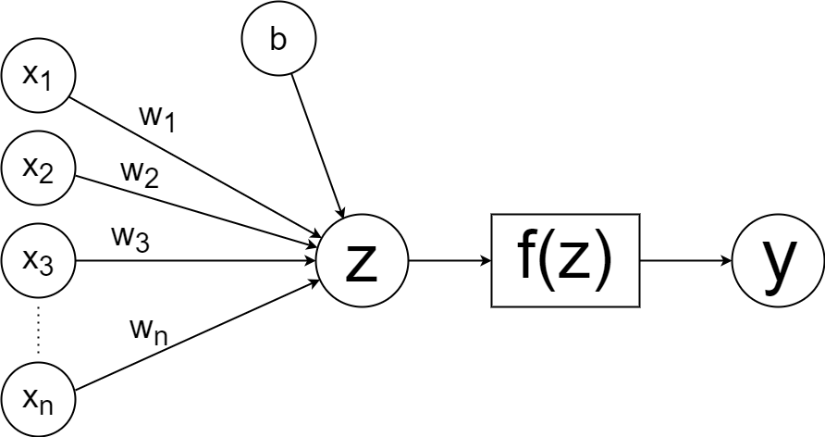 The intermediate value of a neuron, denoted as *z*, is weighted sum of previoud neuron values plus a trashold or bias $b$, unique to each neuron and independent of the input data:

$z=\sum_{i=1}^{n}{\left(x_{i}w_{i}\right)+b}$, (6)

For adding nonlinearity into the learning proces, an activation function *f(z)* is applied, which significantly improving the training capabilities of models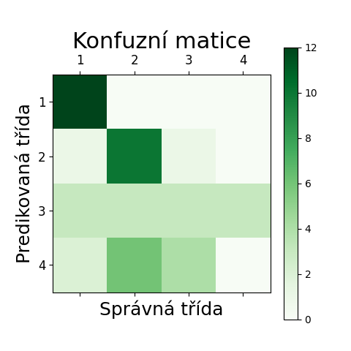. The resulting value of the neuron *y* can then be formulated as:

$y=f\left(z\right)=f\left(\sum_{i=1}^{n}{\left(x_{i}w_{i}\right)+b}\right)$. (7)

The entire process is illustrated in Figure 16.

As the previous text suggests, neurons in neural networks are arranged into layers. The first, input layer merely takes data from the input. He is followed by several hidden layers, each of which can have a different number of neurons. The last layer is called output. In the case of classification it has exactly as many neurons as there are output classes and values of these neurons are probabilities of each class. See Figure 15.

In the case of classification models, the results can also be interpreted using a confusion matrix. Its columns contain information about the correct assignment of output, while rows indicate the model's assignments. By looking at Figure 19, it can be seen that the model predicted classification into four classes; the first class was predicted perfectly, the second with minor errors, the samples of the third class were often misclassified as samples of all classes, and the fourth class was never correctly predicted, being most often confused with the second class.

Figure 19: Example of a confusion matrix

### Introduction to Convolutional Neural Networks - KDnuggetsConvolutional Neural Networks

Figure 20: Calculation of neuron values in a convolutional network [44]

A Convolutional Neural Network (CNN) is a neural network specialized for image processing. Unlike basic feedforward networks, CNNs use the spatial layout of 2D input data (pixels) to capture relationships within images. Instead of connecting every neuron to all neurons in the previous layer, CNN neurons focus on smaller regions, enabling operations like max-pooling for better feature extraction. Figure 20 ilustrates how is the value of neuron calculated.

# Sunspot classification using AI

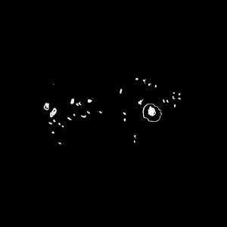The aim of the work was to create a convolutional model that can successfully predict the classification of sunspot groups according to the McIntosh system based on the data collected so far. We utilize 7,170 drawings from the period between 1971 and October 6, 2023. The observatory also provided us with electronic data containing the locations and classifications of 56,375 spots from March 25, 1944, to October 19, 2023. Another reason for selecting this classification is that it has three nearly independent subclasses, allowing us to examine the success rate for each subclass separately. Last but not least, it can be stated that this system is currently the most accurate, considering its global use.

After adequately preparing the input drawings, we were able to use them to train the model. We divided the data into three sets: 80% for training, 10% for validation, and 10% for testing the model's accuracy. During the development of the convolutional networks, we created several datasets and tested various combinations of the neural network's adjustable parameters. The entire process, including the modification of the drawings, was programmed in Python with the help of libraries such as TensorFlow and Keras. We wrote the source code using Visual Studio Code, connected to a GitHub repository [57] to continuously save our work to cloud storage.

Figure 22: Input data on which we trained the model; this is group Fsi.

### Modification of the Input Drawing

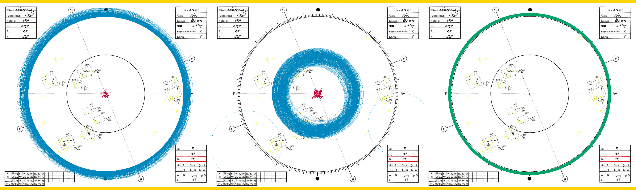Firstly, we change input width of every input protocol to 2000 px. Changing the dimensions of all images to nearly the same values is important because, during model training, we want it to have a correct understanding of the relative size of the groups on the disk. We then placed the image on a blank canvas. In the next step, we centret all images by detecting both auxiliary circles, as shown in Figure 23. The last step before machine searching for groups was applying a mask that covered the tables in the corners, as the program would detect these rectangular tables as well.

Figure 24: The process of modifying a copy of the drawing to improve detection quality; in the upper left, the drawing with removed tables, in the upper right, the drawing after the first pixel replacement, in the lower left, the drawing after blurring, in the lower right, the drawing after the second pixel replacement.

### Detection of Rectangles

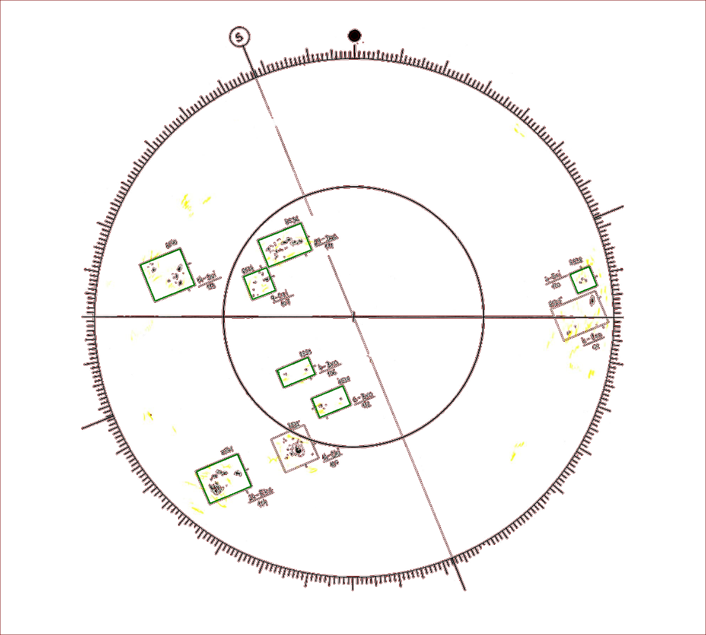In the next step, due to the varying quality of the scan we improve the detection process by appling filters like blour or enhancing contrast. This step ensured that if a line was interrupted or weakened at any point, it would be connected. The process can be seen in Figure 24.

Figure 23: Example of machine detection of the large and small auxiliary circles; on the left, detection of the large circle with marked centers of detected circles, in the middle the same detection for the small circle, on the right, the machine-estimated position of the large circle with its center.

Next, various shapes were machine-found on the modified copy of the drawing. If these shapes were reasonably sized rectangles, we considered the area to be correctly detected as a group. The correctly detected shapes are marked in green in Figure 25. We extracted an area of 300×300 px around the center of the detected shape only for such detected groups and saved it, as shown in Figure 26. We also stored the coordinates of the rectangle corners in a CSV table for further use.

Figure 25: Example of group detection; green detected groups of spots, brown detected other shapes.

### Classification of data

We calculated the heliographic latitude, the lengths of the sunspot disk center, and the angle at which the Sun's rotational axis is tilted for each drawing based on the time data. These values are also listed in the drawing protocol, but it is easier to compute them than to read them directly from the protocol using Optical Character Recognition (OCR) [58]. The program also determines the positional angle of each group and its distance from the center. From this data, we can calculate the heliographic latitude and height of the sunspot group, using the equations (3, 4, 5) provided in Chapter 3.5.2. Subsequently, we identified the sunspot record in the table provided by the Astronomical Institute and found its classification according to the McIntosh system. We then created the necessary folder structure containing the annotated input data. The main folder contained directories named after the individual classes, and these folders contained images of the groups with that classification. From this structure, we could then select only the groups of interest and use them to train the supervised model, as described in Chapter 4.

### Data Preparation for Training

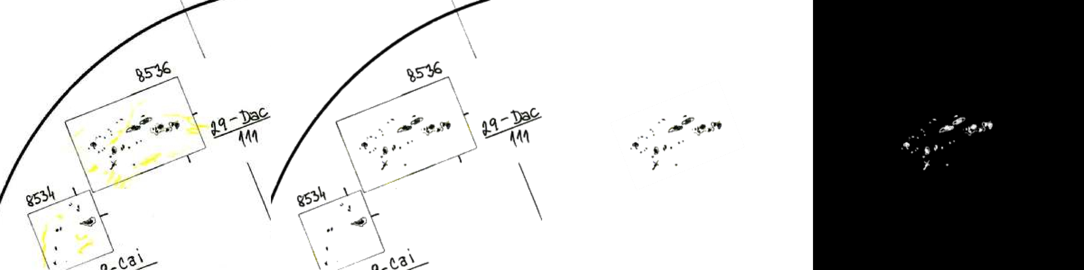To simplify the functioning of the model, we decided to work with black-and-white images. The orange-yellow parts of the image (faculae) were then programmatically removed, and the image was converted to black-and-white. After a manual check, a white mask was applied to the group, covering the surrounding area and leaving only the interior of the rectangle with the spot. Lastly, we inverted the image, as the model worked better with a black background. Figure 26 provides a view of the modification of the group.

We then divided the data necessary for creating the current model into training, validation, and testing directories.

Figure 26: Adjustment of individual groups of spots to final form; on the far left, the extracted part of the drawing 300×300 px around the detected group, in the middle left, the group after removing penumbra areas, in the middle right, the surrounding area of the group covered, on the far right, the final form of the group.

## Model Architecture

Once we had prepared the desired structure for creating the convolutional neural network, we could begin training the individual models. In training all the models, we suitably chose the following parameters:

1. Batch size: The number of input data for one backpropagation process.
2. Steps per epoch: The number of learning steps within one epoch.
3. Validation steps: The number of validation steps for ongoing evaluation at the end of each epoch.
4. Number and structure of layers: The number and type of layers, the number of neurons in them, and the activation functions.

After training, we considered the best model to be the one with the lowest loss function value on the validation data. The final results were than evaluated on the test data, which the model had not accessed during training and validation.

# Results of the work

## Classification into Two Classes

### Model Axx-Dai

|  |  |  |  |  |  |  |
| --- | --- | --- | --- | --- | --- | --- |
| Počet tříd | Celkem vzorků | Počet vzorků v třídách Axx, Dai | Batch size | Steps per epoch | Validation steps | Počet vrstev včetně výstupní |
| 2 | 2499 | 1668, 831 | 32 | 24 | 38 | 7 |

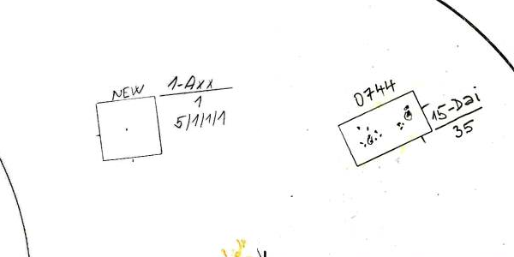This model is expected to be very accurate in distinguishing between groups Axx and Dai, as the difference between these two groups is enormous. The Axx group consists of a solitary small spot, whereas the Dai group includes penumbrae, is noticeably larger, and, unlike the Axx group, the spots are more distributed towards the poles of the group rather than in its center. Both groups are shown in Figure 27. Additionally, we had hundreds of images of both groups, which also contributes to accuracy. The parameters for the neural network were set as follows:

Figure 27: Classes of the model Axx-Dai.

Table 1: Input data and parameters of the CNN model Axx-Dai

With this combination of parameters, we obtained overall accuracy: 98.21 %. Therefore the model learned to differentiate between the classes with nearly absolutely perfect. This result was expected, as ideal conditions were established: noticeable diversity between classes, a large number of input data, and a simple structure.

### Model Axx-Bxo

|  |  |  |  |  |  |  |
| --- | --- | --- | --- | --- | --- | --- |
| Počet tříd | Celkem vzorků | Počet vzorků v třídách Axx, Bxo | Batch size | Steps per epoch | Validation steps | Počet vrstev včetně výstupní |
| 2 | 3429 | 1668, 1761 | 32 | 20 | 60 | 5 |

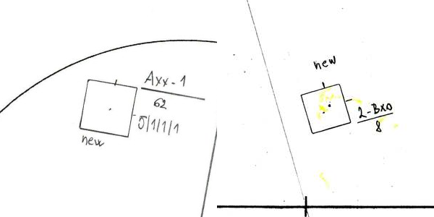In comparison to the previous model Axx-Dai, the Axx-Bxo model is expected to be less accurate because the Axx and Bxo groups differ significantly less from one another. The main distinction between these groups is that Axx represents a single spot, whereas Bxo consists of multiple spots. The appearances of both classes are illustrated in Figure 28. This fact should allow the convolutional neural network to learn to differentiate between them relatively well. Furthermore, we have a substantial amount of data available from both classes, which should also enhance accuracy. The parameters for the convolutional network were set as follows:

Table 2: Input data and parameters of the CNN model Axx-Bxo

Figure 28: Classes of the model Axx-Bxo.

With this combination of parameters, we obtained the overall accuracy: 89.52 %. It is evident that the model learned to recognize both categories quite well. The accuracy could potentially be increased by adding more layers. Another option to improve model performance would be to crop the input images to a smaller size, as both groups, Axx and Bxo, are relatively small.

## Classification into Four Classes

Models should still classify groups into the correct categories with high accuracy; however, they are generally not expected to be more accurate than the two-class models, as accuracy tends to decrease with an increasing number of classes.

### Model Axx-Csi-Eac-Hsx

|  |  |  |  |  |  |  |
| --- | --- | --- | --- | --- | --- | --- |
| Počet tříd | Celkem vzorků | Počet vzorků v třídách Axx, Csi, Eac, Hsx | Batch size | Steps per epoch | Validation steps | Počet vrstev včetně výstupní |
| 4 | 3991 | 1668, 572, 206, 1545 | 20 | 96 | 128 | 7 |

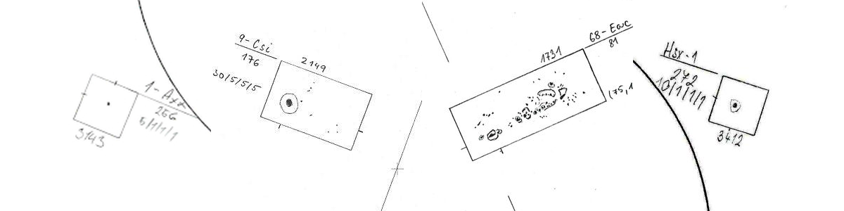In creating the dataset, we intentionally selected four distinct groups, so the neural network should be able to detect these significant differences. The Axx group is simply a unipolar spot. The Csi group contains only one spot with a penumbra, while the other groups do not. The Eac group is the most complex of these data, containing both spots with and without penumbra, and the distribution of spots is compact. The Hsx group is also a unipolar spot like Axx, but in contrast, it features a penumbra. All class representations are shown in Figure 29. Thus, it is likely that the model will make errors primarily between the Csi and Eac groups or between Axx and Hsx, rather than between other combinations, as these pairs are the least distinct yet still markedly different. The parameters for the convolutional network were set as follows:

Table 3: Input data and parameters of the CNN model Axx-Csi-Eac-Hsx

Figure 29: Classes of the model Axx-Csi-Eac-Hsx.

With this combination of parameters, we obtained overall accuracy on test data: 92.86 %. The convolutional neural network achieved a very accurate prediction of individual classes, with an accuracy close to 93 %. Confusion Matrix 1 can be viewed in Figure 31. Additionally, we can clearly observe the correlation between the number of classes and overall accuracy, as the Axx-Dai model achieved an accuracy of 98.21 %. For both of these models, we intentionally selected very different input data.

### Model Axx-Bxi-Cai-Cso

|  |  |  |  |  |  |  |
| --- | --- | --- | --- | --- | --- | --- |
| Počet tříd | Celkem vzorků | Počet vzorků v třídách Axx, Bxi, Cai, Cso | Batch size | Steps per epoch | Validation steps | Počet vrstev včetně výstupní |
| 4 | 4233 | 1668, 1134, 662, 769 | 32 | 14 | 36 | 7 |

The model attempting to classify groups of sunspots into classes Axx, Bxi, Cai, and Cso has a relatively complex task. Unlike the classes of the previous model, these classes do not differ significantly from one another. The groups beginning with the letter C feature spots with a penumbra, which the model should ideally learn to recognize. The distinction between the Cso and Cai groups lies, in addition to the shape of the penumbra, in the arrangement of spots within the group; one group has an open distribution of spots, while the other has a transitional arrangement, meaning spots also appear in the center of the group. The Bxi group contains only umbral spots distributed throughout its area. The Axx group consists of a single unipolar spot. All groups are shown in Figure 30. The parameters for the neural network were set as follows:

Figure 30: Classes of the model Axx-Bxi-Cai-Cso.

Table 4: Input data and parameters of the CNN model Axx-Bxi-Cai-Cso

With this combination of parameters, we obtained overall accuracy: 66.05 %.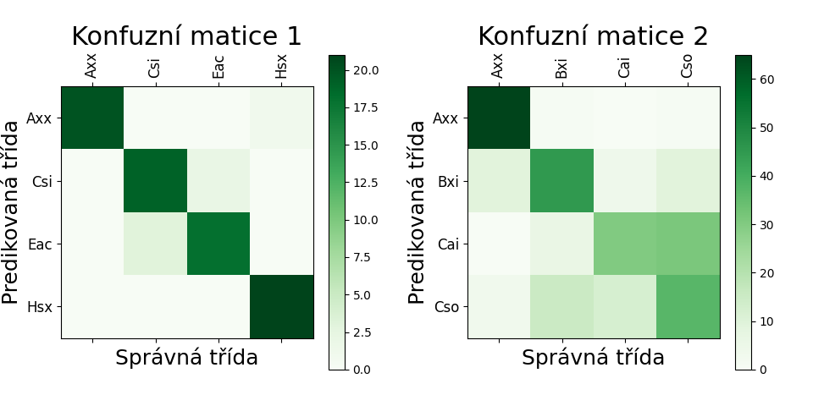 It is entirely evident that with these input data the model did not perform as well as in previous cases. The main problem lies in the data themselves, which are very similar to each other. Looking at confusion matrix 2, see Figure 31, we can observe that group Axx was predicted correctly 65 times and incorrectly only twice, but class Cai was in approximately half the cases confused with class Cso. The class Cso was then evenly misclassified as class Bxi and class Cso.

Figure 31: Confusion matrix of the four-class models; on the left, the model Axx-Csi-Eac-Hsx, on the right, the model Axx-Bxi-Cai-Cso.

## Final Class Model

We also wanted to to train model including every class. Unfortunately, there were some classes with low on zero samples, which make it impossible task. In that regard we exclude 10 classes of 60 possible. Unfortunately becaous of diamtericly different number of samples across individual classes, this model unfortunately achieved an extremely low accuracy. If we looked at the prediction accuracies of individual letters, we would find that the first letter was correctly detected in 45% of cases, the second letter in only 36%, and the distribution of spots was managed with an accuracy of 46%. Even though these numbers may seem relatively successful, combining these values yielded an overall accuracy of only 8%. This example clearly illustrates how important it is for each part of the model’s output detection to be accurate.

## Classification by Letters

Given the challenges we encountered due to the lack of data for specific classes during the model creation, an option arose to train a separate neural network model for each subclassification. This approach dramatically reduces the number of classes that the model predicts and significantly increases the number of samples in each class. We thus created datasets by grouping all samples with a specific subclassification into the same class. For instance, when creating a model that predicts the first letter, all samples from classes Hax, Hhx, Hkx, Hrx, and Hsx would be placed into class H.

### Model A-B-C-D-E-F-H

|  |  |  |  |  |  |  |
| --- | --- | --- | --- | --- | --- | --- |
| Počet tříd | Celkem vzorků | Počet vzorků v třídách  A, B, C, D, E, F, H | Batch size | Steps per epoch | Validation steps | Počet vrstev včetně výstupní |
| 7 | 14 768 | 1668, 2895, 3479, 2872, 1046, 131, 2427 | 32 | 28 | 56 | 9 |

This model should not encounter problems with classification since it has access to a large amount of input data, classifies into a small number of classes, and the differences between the classes are mostly readily visible, as illustrated in Figure 9. The parameters for the convolutional network were set as follows:

Table 5: Input data and parameters of the CNN model A-B-C-D-E-F-H

With this combination of parameters, we obtained overall accuracy: 61.22 %. The results indicate that the model achieved relatively decent outcomes. Its accuracy is comparable to the Axx-Bxi-Cai-Cso model. By examining Confusion Matrix 1, see Figure 32, we can see that the model's main inaccuracy lies between groups DEF, which we know, only differs in size.

### Model a-h-k-r-s-x

It could be expected that the model for the second subclassification will be less accurate than both other letter models since this subclassification refers only to the largest spot, whose relative position within the group is always different, making it difficult to precisely determine where this important spot is located in the image. The parameters for the convolutional network were set as follows:

|  |  |  |  |  |  |  |
| --- | --- | --- | --- | --- | --- | --- |
| Počet tříd | Celkem vzorků | Počet vzorků v třídách  a, h, k, r, s, x | Batch size | Steps per epoch | Validation steps | Počet vrstev včetně výstupní |
| 6 | 14 768 | 3564, 291, 1001, 1280, 3819, 4563 | 48 | 64 | 108 | 7 |

Table 6: Input data and parameters of the CNN model a-h-k-r-s-x

With this combination of parameters, we obtained o verall accuracy: 50.00%. By examining Confusion Matrix 2, see Figure 32, we can see that the model struggled with two classes. One of these is class h, which was expected due to the lower number of input data. The second class causing problems for the model is class r due to its similarity with class x. Furthermore, these two classes logically do not overlap. The label x can only be used if it pertains to group A or B, while the label r is used in the exact opposite case. This logic could be implemented in the final model, significantly increasing the accuracy.

### Model c-i-o-x

|  |  |  |  |  |  |  |
| --- | --- | --- | --- | --- | --- | --- |
| Počet tříd | Celkem vzorků | Počet vzorků v třídách  c, i, o, x | Batch size | Steps per epoch | Validation steps | Počet vrstev včetně výstupní |
| 4 | 14 768 | 1 603, 4 776, 4 288, 4 101 | 56 | 72 | 108 | 7 |

We can expect the accuracy of this model to be comparable to the accuracy of predicting the first letter, as there are also noticeable differences between the classes. This subclassification pertains to the overall distribution of spots within the group. Therefore, the model should easily estimate which class it is based on information about whether there are spots in the middle, whether they are located at the edges, and so forth. The parameters were set as follows:

Table 7: Input data and parameters of the CNN model c-i-o-x

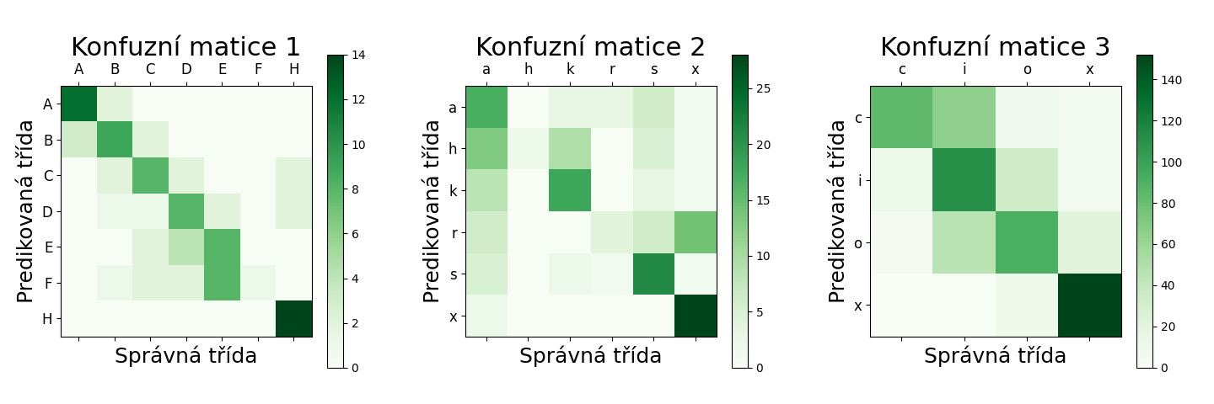With this combination of parameters, we obtained overall accuracy: 68.17%. The accuracy is comparable to that of the model A-B-C-D-E-F-H. Confusion Matrix 3, see Figure 32, reveals that the model most frequently confused class c with class i, but most of the data remains close to the main diagonal.

## Final Letter Model

With all three subclassification models ready, we combined them into a single code block. Each model analyzes the same image independently, and their outputs are merged to generate the final group name. The outcomes of these three subclassification models were as follows:

Figure 32: Confusion matrix of the letter models; on the left, the model A-B-C-D-E-F-H, in the middle, the model a-h-k-r-s-x, on the right, the model c-i-o-x.

* Correct detection of all three letters: 19.02%
* Correct detection of any two letters: 33.74%
* 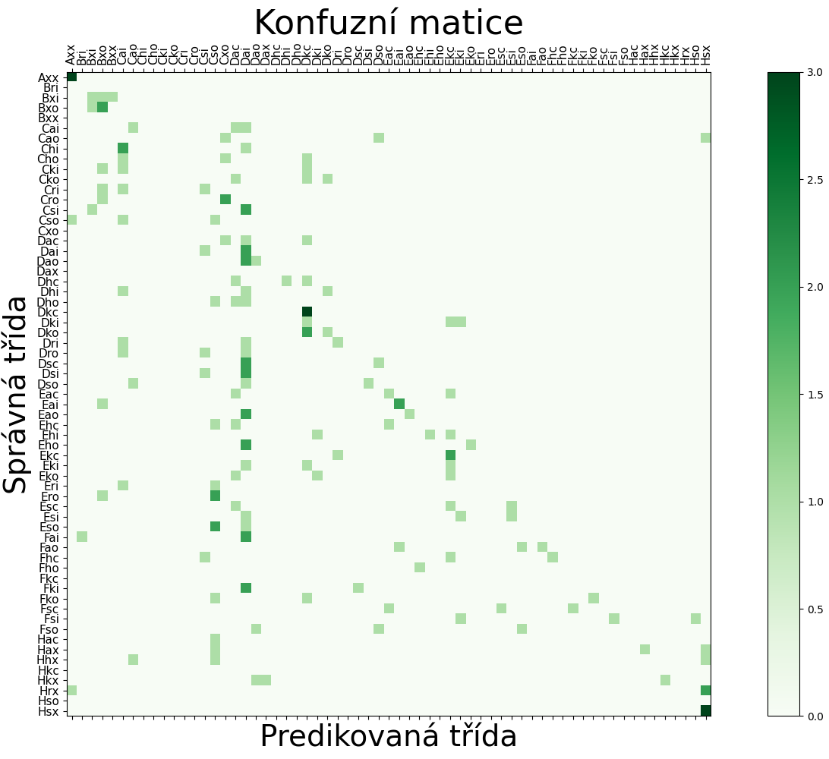Correct detection of only one letter: 32.52%

These results show a significant improvement compared to the final class model, as the accuracy more than doubled. Additionally, in Fugure 33, we can observe that some data points tend to cluster around the diagonal in the confusion matrix. However, the model currently lacks the implementation of information regarding which classes do not exist; for example, some test image was incorrectly labeled as the group "Bri".

# Conclusion

We successfully created a functioning convolutional neural network model capable of classifying groups of sunspots according to the McIntosh system. The work can be understood as proof of concept that machine learning can be applied in a field such as solar astronomy.

The work also includes a detailed section that introduces the problem from the perspective of both branches of science: solar astronomy and machine learning.

Additionally, the work describes the process necessary to create the final model and explores several other possible directions for future development in this field.

## Extension of the Work

### Creation of Additional Models

There are many opportunities to build upon the models developed in this work. Improving sunspot detection in drawings, potentially extracting up to four times more data, could significantly boost accuracy. To access larger datasets, we also explored using drawings from other observatories, such as the Kanzelhöhe Observatory, which kindly shared their data (see Figure 8). However, their sunspot groups lack rectangular boundaries and digital labels and use a different classification system, making them incompatible with this project.

An interesting task would be to incorporate information such as the relative position of the group on the disk and its heliographic coordinates into the input data. The model could then better understand the flattening of some groups at the edge of the solar disk. Another potential extension could be to create a program that would work with data labeled with a non-existent class and attempt to correct this information.

Another approach is to convert sunspot group names into CV index values and predict only the group number. This reduces misclassification by keeping similar groups numerically close.

The data could also be used to train a completely different type of model that could predict the evolution of groups over time, as group development over time can be tracked.

### Implementation by Observatories

Once group detection and classification methods are fully functional and flexible, a program could automatically identify and classify sunspot groups from clean drawings. A prototype was developed during a visit of the Ondřejov Observatory, which processed a drawing, detected sunspots, predicted their class, and labeled them. A final version could serve to similarly to verify manual classifications.

# Extension of the Work

## Creation of Additional Models

There are many opportunities to build upon the models developed in this work. Improving sunspot detection in drawings, potentially extracting up to four times more data, could significantly boost accuracy. To access larger datasets, we also explored using drawings from other observatories, such as the Kanzelhöhe Observatory, which kindly shared their data (see Figure 8). However, their sunspot groups lack rectangular boundaries and digital labels and use a different classification system, making them incompatible with this project.

An interesting task would be to incorporate information such as the relative position of the group on the disk and its heliographic coordinates into the input data. The model could then better understand the flattening of some groups at the edge of the solar disk. Another potential extension could be to create a program that would work with data labeled with a non-existent class and attempt to correct this information.

Another approach is to convert sunspot group names into CV index values and predict only the group number. This reduces misclassification by keeping similar groups numerically close.

The data could also be used to train a completely different type of model that could predict the evolution of groups over time, as group development over time can be tracked.

## Implementation by Observatories

Once group detection and classification methods are fully functional and flexible, a program could automatically identify and classify sunspot groups from clean drawings. A prototype was developed during a visit of the Ondřejov Observatory, which processed a drawing, detected sunspots, predicted their class, and labeled them. A final version could serve to similarly to verify manual classifications.

# Conclusion

We successfully created a functioning convolutional neural network model capable of classifying groups of sunspots according to the McIntosh system. The work can be understood as proof of concept that machine learning can be applied in a field such as solar astronomy.

The work also includes a detailed section that introduces the problem from the perspective of both branches of science: solar astronomy and machine learning.

Additionally, the work describes the process necessary to create the final model and explores several other possible directions for future development in this field.